UNITED STATES
SECURITIES AND EXCHANGE COMMISSION
WASHINGTON, D.C. 20549

FORM 8-K

CURRENT REPORT
Pursuant to Section 13 or 15(d) of the Securities Exchange Act of 1934

Date of report (Date of earliest event reported): August 26, 2026

Gyre Therapeutics, Inc.
(Exact name of registrant as specified in its charter)

Delaware | 000-51173 | 56-2020050
(State or other jurisdiction of incorporation) | (Commission File Number) | (IRS Employer Identification No.)

12730 High Bluff Drive  Suite 250  San Diego, CA |  | 92130
(Address of principal executive offices) |  | (Zip Code)

Registrant’s telephone number, including area code: (858) 284-0115

N/A
(Former name or former address, if changed since last report)

Check the appropriate box below if the Form 8-K filing is intended to simultaneously satisfy the filing obligation of the registrant under any of the following provisions (see General Instruction A.2. below):

☐ | Written communications pursuant to Rule 425 under the Securities Act (17 CFR 230.425)

☐ | Soliciting material pursuant to Rule 14a-12 under the Exchange Act (17 CFR 240.14a-12)

☐ | Pre-commencement communications pursuant to Rule 14d-2(b) under the Exchange Act (17 CFR 240.14d-2(b))

☐ | Pre-commencement communications pursuant to Rule 13e-4(c) under the Exchange Act (17 CFR 240.13e-4(c))

Securities registered pursuant to Section 12(b) of the Act:

Title of each class |  | Trading Symbol(s) |  | Name of each exchange on which  registered
Common Stock |  | GYRE |  | The Nasdaq Capital Market

Indicate by check mark whether the registrant is an emerging growth company as defined in Rule 405 of the Securities Act of 1933 (§230.405 of this chapter) or Rule 12b-2 of the Securities Exchange Act of 1934 (§240.12b-2 of this chapter).

Emerging growth company ☐

If an emerging growth company, indicate by check mark if the registrant has elected not to use the extended transition period for complying with any new or revised financial accounting standards provided pursuant to Section 13(a) of the Exchange Act. ☐

Item 7.01 | Regulation FD Disclosure.

On August 26, 2026, Gyre Therapeutics, Inc. (the “Company”) made available an updated corporate presentation on the Company’s website.

A copy of the corporate presentation is furnished as Exhibit 99.1 to this Current Report on Form 8-K and is incorporated by reference herein. The exhibit furnished under Item 7.01 of this Current Report on Form 8-K shall not be deemed to be “filed” for purposes of Section 18 of the Securities Exchange Act of 1934, as amended (the “Exchange Act”), or otherwise subject to the liabilities of that section, nor shall it be deemed incorporated by reference in any filing under the Exchange Act or the Securities Act of 1933, as amended, regardless of any general incorporation language in such filing.

Item 9.01 | Financial Statements and Exhibits.

(d) Exhibits.

Exhibit  Number |  | Exhibit Title or Description
99.1 |  | Corporate Presentation, dated August 2026
104 |  | Cover page interactive data file (embedded within the Inline XBRL document)

SIGNATURE

Pursuant to the requirements of the Securities Exchange Act of 1934, the registrant has duly caused this report to be signed on its behalf by the undersigned hereunto duly authorized.

 | GYRE THERAPEUTICS, INC.
Date: August 26, 2026 | By: | /s/ Thomas Eastling
 | Name: | Thomas Eastling
 | Title: | Chief Financial Officer

Exhibit 99.1


1 August 2026 Building A New Protein Degrader Company For Unmet Medical Needs

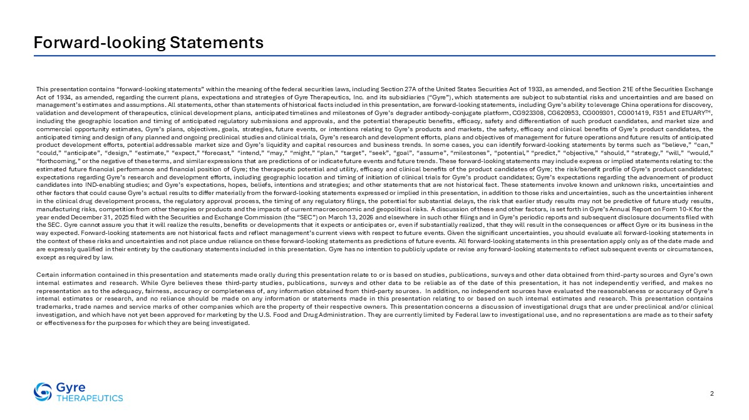
This presentation contains “forward-looking statements” within the meaning of the federal securities laws, including Section 27A of the United States Securities Act of 1933, as amended, and Section 21E of the Securities Exchange Act of 1934, as amended, regarding the current plans, expectations and strategies of Gyre Therapeutics, Inc. and its subsidiaries (“Gyre”), which statements are subject to substantial risks and uncertainties and are based on management’s estimates and assumptions. All statements, other than statements of historical facts included in this presentation, are forward-looking statements, including Gyre’s ability to leverage China operations for discovery, validation and development of therapeutics, clinical development plans, anticipated timelines and milestones of Gyre’s degrader antibody-conjugate platform, CG923308, CG620953, CG009301, CG001419, F351 and ETUARYTM, including the geographic location and timing of anticipated regulatory submissions and approvals, and the potential therapeutic benefits, efficacy, safety and differentiation of such product candidates, and market size and commercial opportunity estimates, Gyre’s plans, objectives, goals, strategies, future events, or intentions relating to Gyre’s products and markets, the safety, efficacy and clinical benefits of Gyre’s product candidates, the anticipated timing and design of any planned and ongoing preclinical studies and clinical trials, Gyre’s research and development efforts, plans and objectives of management for future operations and future results of anticipated product development efforts, potential addressable market size and Gyre’s liquidity and capital resources and business trends. In some cases, you can identify forward-looking statements by terms such as “believe,” “can,” “could,” “anticipate”, “design,” “estimate,” “expect,” “forecast,” “intend,” “may,” “might,” “plan,” “target”, “seek”, “goal”, “assume”, “milestones”, “potential,” “predict,” “objective,” “should,” “strategy,” “will,” “would,” “forthcoming,” or the negative of these terms, and similar expressions that are predictions of or indicate future events and future trends. These forward-looking statements may include express or implied statements relating to: the estimated future financial performance and financial position of Gyre; the therapeutic potential and utility, efficacy and clinical benefits of the product candidates of Gyre; the risk/benefit profile of Gyre’s product candidates; expectations regarding Gyre’s research and development efforts, including geographic location and timing of initiation of clinical trials for Gyre’s product candidates; Gyre’s expectations regarding the advancement of product candidates into IND-enabling studies; and Gyre’s expectations, hopes, beliefs, intentions and strategies; and other statements that are not historical fact. These statements involve known and unknown risks, uncertainties and other factors that could cause Gyre’s actual results to differ materially from the forward-looking statements expressed or implied in this presentation, in addition to those risks and uncertainties, such as the uncertainties inherent in the clinical drug development process, the regulatory approval process, the timing of any regulatory filings, the potential for substantial delays, the risk that earlier study results may not be predictive of future study results, manufacturing risks, competition from other therapies or products and the impacts of current macroeconomic and geopolitical risks. A discussion of these and other factors, is set forth in Gyre’s Annual Report on Form 10-K for the year ended December 31, 2025 filed with the Securities and Exchange Commission (the “SEC”) on March 13, 2026 and elsewhere in such other filings and in Gyre’s periodic reports and subsequent disclosure documents filed with the SEC. Gyre cannot assure you that it will realize the results, benefits or developments that it expects or anticipates or, even if substantially realized, that they will result in the consequences or affect Gyre or its business in the way expected. Forward-looking statements are not historical facts and reflect management’s current views with respect to future events. Given the significant uncertainties, you should evaluate all forward-looking statements in the context of these risks and uncertainties and not place undue reliance on these forward-looking statements as predictions of future events. All forward-looking statements in this presentation apply only as of the date made and are expressly qualified in their entirety by the cautionary statements included in this presentation. Gyre has no intention to publicly update or revise any forward-looking statements to reflect subsequent events or circumstances, except as required by law. Certain information contained in this presentation and statements made orally during this presentation relate to or is based on studies, publications, surveys and other data obtained from third-party sources and Gyre’s own internal estimates and research. While Gyre believes these third-party studies, publications, surveys and other data to be reliable as of the date of this presentation, it has not independently verified, and makes no representation as to the adequacy, fairness, accuracy or completeness of, any information obtained from third-party sources. In addition, no independent sources have evaluated the reasonableness or accuracy of Gyre’s internal estimates or research, and no reliance should be made on any information or statements made in this presentation relating to or based on such internal estimates and research. This presentation contains trademarks, trade names and service marks of other companies which are the property of their respective owners. This presentation concerns a discussion of investigational drugs that are under preclinical and/or clinical investigation, and which have not yet been approved for marketing by the U.S. Food and Drug Administration. They are currently limited by Federal law to investigational use, and no representations are made as to their safety or effectiveness for the purposes for which they are being investigated. 2 Forward-looking Statements

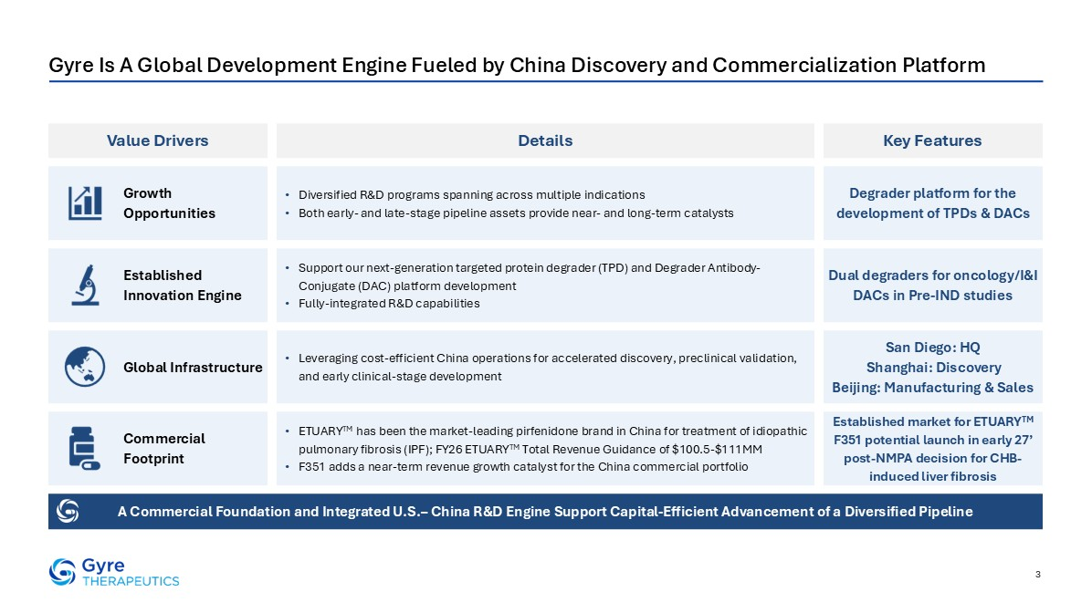
3 Gyre Is A Global Development Engine Fueled by China Discovery and Commercialization Platform Value Drivers Key Features Details A Commercial Foundation and Integrated U.S.– China R&D Engine Support Capital-Efficient Advancement of a Diversified Pipeline Growth Opportunities Established Innovation Engine Global Infrastructure Commercial Footprint Diversified R&D programs spanning across multiple indications Both early- and late-stage pipeline assets provide near- and long-term catalysts Support our next-generation targeted protein degrader (TPD) and Degrader Antibody-Conjugate (DAC) platform development Fully-integrated R&D capabilities Leveraging cost-efficient China operations for accelerated discovery, preclinical validation, and early clinical-stage development ETUARYTM has been the market-leading pirfenidone brand in China for treatment of idiopathic pulmonary fibrosis (IPF); FY26 ETUARYTM Total Revenue Guidance of $100.5-$111MM F351 adds a near-term revenue growth catalyst for the China commercial portfolio Degrader platform for the development of TPDs & DACs Dual degraders for oncology/I&I DACs in Pre-IND studies Established market for ETUARYTM F351 potential launch in early 27’ post-NMPA decision for CHB-induced liver fibrosis San Diego: HQ Shanghai: Discovery Beijing: Manufacturing & Sales

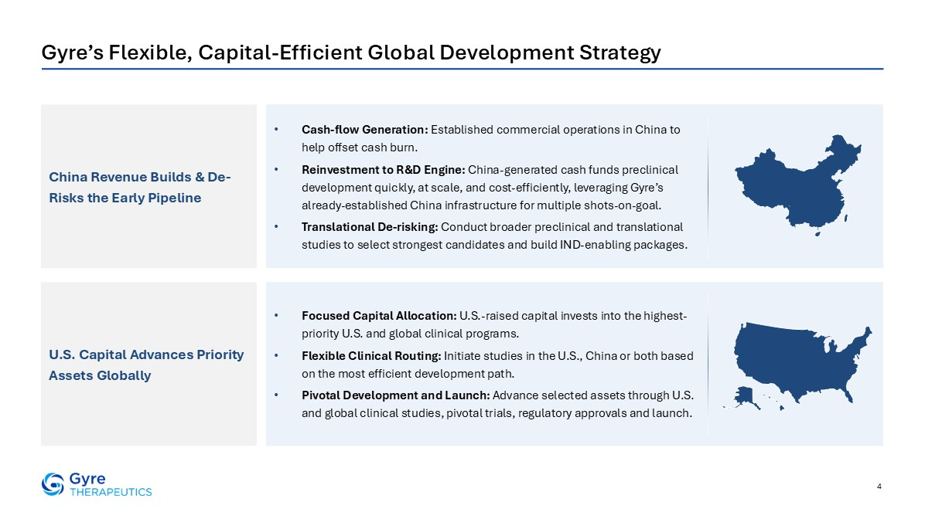
4 Gyre’s Flexible, Capital-Efficient Global Development Strategy China Revenue Builds & De-Risks the Early Pipeline U.S. Capital Advances Priority Assets Globally Cash-flow Generation: Established commercial operations in China to help offset cash burn. Reinvestment to R&D Engine: China-generated cash funds preclinical development quickly, at scale, and cost-efficiently, leveraging Gyre’s already-established China infrastructure for multiple shots-on-goal. Translational De-risking: Conduct broader preclinical and translational studies to select strongest candidates and build IND-enabling packages. Focused Capital Allocation: U.S.-raised capital invests into the highest-priority U.S. and global clinical programs. Flexible Clinical Routing: Initiate studies in the U.S., China or both based on the most efficient development path. Pivotal Development and Launch: Advance selected assets through U.S. and global clinical studies, pivotal trials, regulatory approvals and launch.

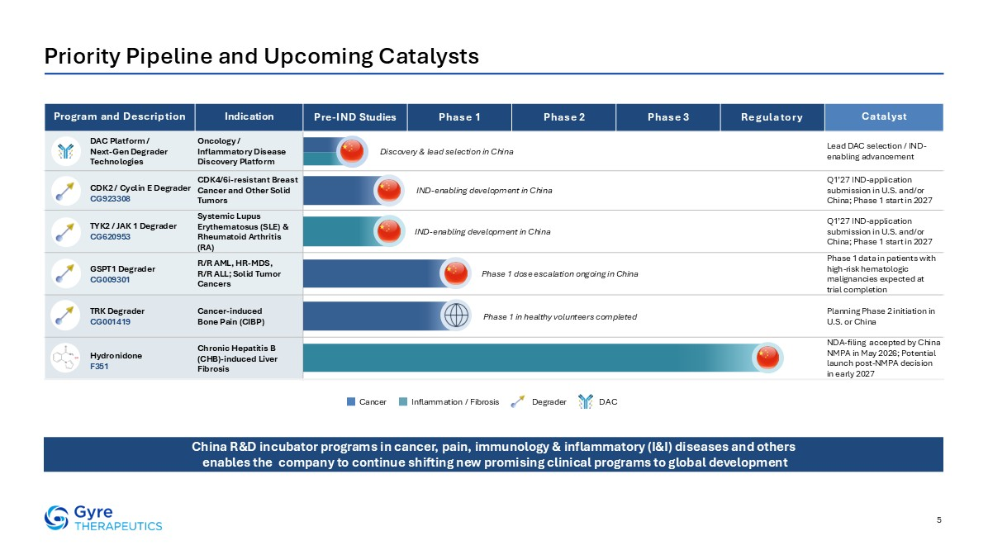
Priority Pipeline and Upcoming Catalysts Program and Description Indication Pre-IND Studies Phase 1 Phase 2 Phase 3 Regulatory Catalyst DAC Platform / Next-Gen Degrader Technologies Oncology / Inflammatory Disease Discovery Platform Lead DAC selection / IND-enabling advancement CDK2 / Cyclin E DegraderCG923308 CDK4/6i-resistant Breast Cancer and Other Solid Tumors Q1’27 IND-application submission in U.S. and/or China; Phase 1 start in 2027 TYK2 / JAK 1 Degrader CG620953 Systemic Lupus Erythematosus (SLE) & Rheumatoid Arthritis (RA) Q1’27 IND-application submission in U.S. and/or China; Phase 1 start in 2027 GSPT1 Degrader CG009301 R/R AML, HR-MDS, R/R ALL; Solid Tumor Cancers Phase 1 data in patients with high-risk hematologic malignancies expected at trial completion TRK Degrader CG001419 Cancer-induced Bone Pain (CIBP) Planning Phase 2 initiation in U.S. or China Hydronidone F351 Chronic Hepatitis B (CHB)-induced Liver Fibrosis NDA-filing accepted by China NMPA in May 2026; Potential launch post-NMPA decision in early 2027 Inflammation / Fibrosis Cancer Degrader DAC China R&D incubator programs in cancer, pain, immunology & inflammatory (I&I) diseases and others enables the company to continue shifting new promising clinical programs to global development 5 Discovery & lead selection in China IND-enabling development in China IND-enabling development in China Phase 1 dose escalation ongoing in China Phase 1 in healthy volunteers completed


Targeted Protein Degraders (TPDs)

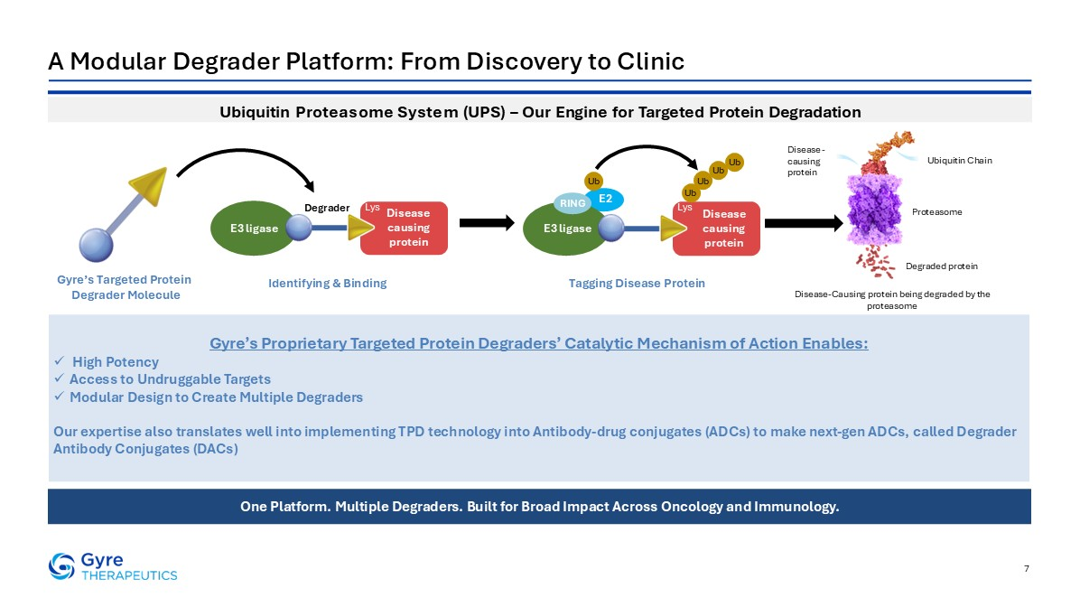
7 A Modular Degrader Platform: From Discovery to Clinic One Platform. Multiple Degraders. Built for Broad Impact Across Oncology and Immunology. Gyre’s Proprietary Targeted Protein Degraders’ Catalytic Mechanism of Action Enables: High Potency Access to Undruggable Targets Modular Design to Create Multiple Degraders Our expertise also translates well into implementing TPD technology into Antibody-drug conjugates (ADCs) to make next-gen ADCs, called Degrader Antibody Conjugates (DACs) Ubiquitin Proteasome System (UPS) – Our Engine for Targeted Protein Degradation Disease causing protein Lys E3 ligase Degrader Disease causing protein Lys E3 ligase RING Ub Ub Ub Ub Ub E2 Gyre’s Targeted Protein Degrader Molecule Identifying & Binding Tagging Disease Protein Disease-Causing protein being degraded by the proteasome Degraded protein Proteasome Ubiquitin Chain Disease-causing protein

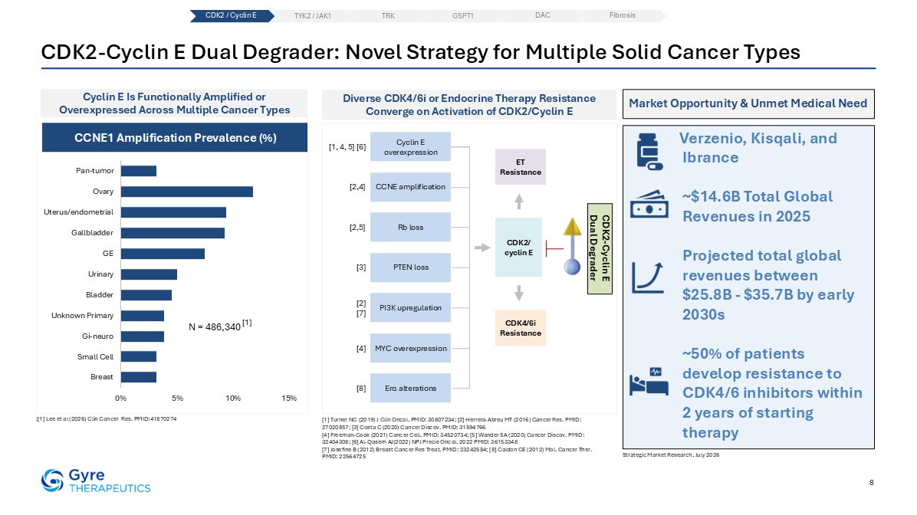
8 CDK2-Cyclin E Dual Degrader: Novel Strategy for Multiple Solid Cancer Types Cyclin E Is Functionally Amplified or Overexpressed Across Multiple Cancer Types :[1] Lee et al (2026) Clin Cancer Res. PMID:41870274 [1] Turner NC (2019) J Clin Oncol. PMID: 30807234; [2] Herrera-Abreu MT (2016) Cancer Res. PMID: 27020857; [3] Costa C (2020) Cancer Discov. PMID: 31594766 [4] Freeman-Cook (2021) Cancer Cell. PMID: 34520734; [5] Wander SA (2020) Cancer Discov. PMID: 32404308; [6] Al-Qasem AJ(2022) NPJ Precis Oncol. 2022 PMID: 36153348 [7] Josefine B (2012) Breast Cancer Res Treat. PMID: 23242584; [8] Caldon CE (2012) Mol. Cancer Ther. PMID: 22564725 Diverse CDK4/6i or Endocrine Therapy Resistance Converge on Activation of CDK2/Cyclin E N = 486,340 CDK2-Cyclin E Dual Degrader Cyclin E overexpression CCNE amplification Rb loss PTEN loss PI3K upregulation MYC overexpression Erα alterations ET Resistance CDK2/ cyclin E CDK4/6i Resistance [1, 4, 5] [6] [2,4] [2,5] [3] [2] [7] [4] [8] CCNE1 Amplification Prevalence (%) [1] Market Opportunity & Unmet Medical Need Verzenio, Kisqali, and Ibrance ~$14.6B Total Global Revenues in 2025 Projected total global revenues between $25.8B - $35.7B by early 2030s ~50% of patients develop resistance to CDK4/6 inhibitors within 2 years of starting therapy Strategic Market Research, July 2026 CDK2 / Cyclin E TYK2 / JAK1 TRK DAC Fibrosis GSPT1

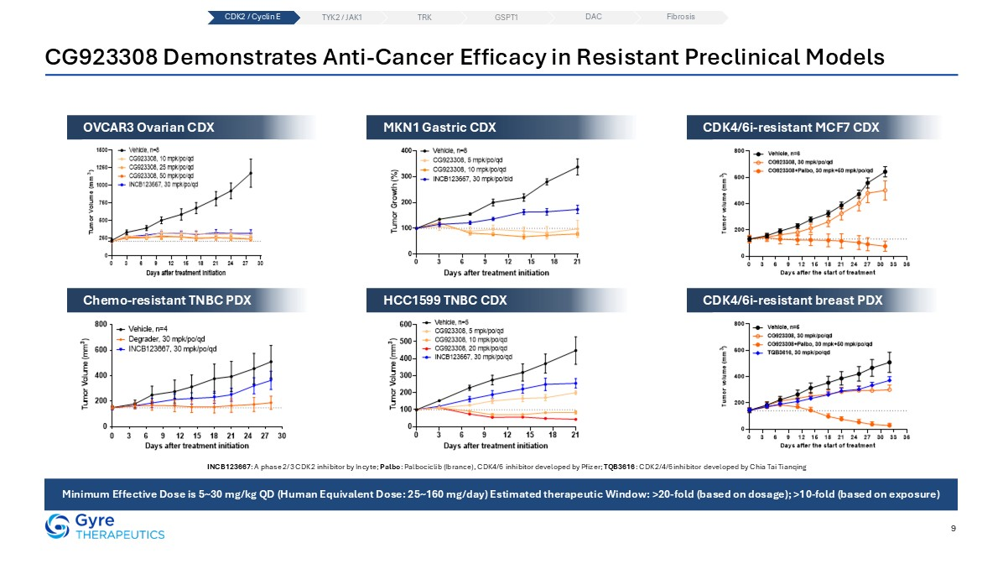
CG923308 Demonstrates Anti-Cancer Efficacy in Resistant Preclinical Models 9 Minimum Effective Dose is 5~30 mg/kg QD (Human Equivalent Dose: 25~160 mg/day) Estimated therapeutic Window: >20-fold (based on dosage); >10-fold (based on exposure) MKN1 Gastric CDX HCC1599 TNBC CDX OVCAR3 Ovarian CDX Chemo-resistant TNBC PDX CDK4/6i-resistant MCF7 CDX CDK4/6i-resistant breast PDX INCB123667: A phase 2/3 CDK2 inhibitor by Incyte; Palbo: Palbociclib (Ibrance), CDK4/6 inhibitor developed by Pfizer; TQB3616: CDK2/4/6 inhibitor developed by Chia Tai Tianqing CDK2 / Cyclin E TYK2 / JAK1 TRK DAC Fibrosis GSPT1

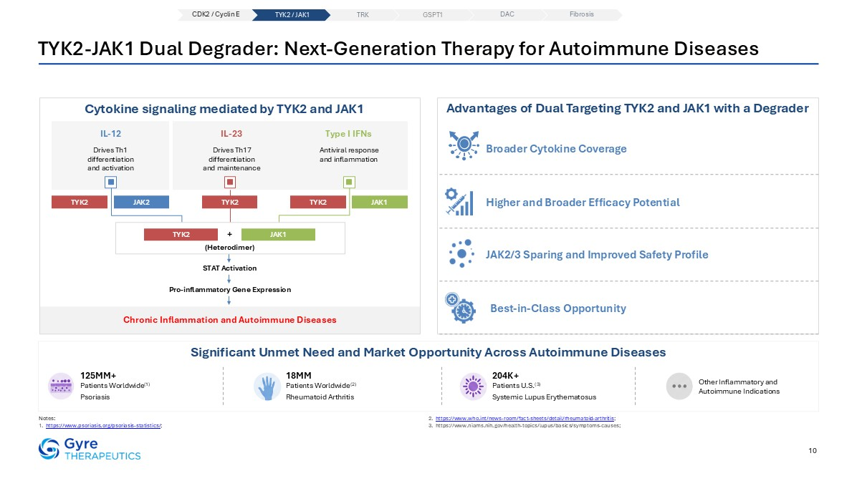
JAK2/3 Sparing and Improved Safety Profile Chronic Inflammation and Autoimmune Diseases 10 TYK2-JAK1 Dual Degrader: Next-Generation Therapy for Autoimmune Diseases Notes: https://www.psoriasis.org/psoriasis-statistics/; https://www.who.int/news-room/fact-sheets/detail/rheumatoid-arthritis; https://www.niams.nih.gov/health-topics/lupus/basics/symptoms-causes; Significant Unmet Need and Market Opportunity Across Autoimmune Diseases Cytokine signaling mediated by TYK2 and JAK1 125MM+ Patients Worldwide(1) Psoriasis 18MM Patients Worldwide(2) Rheumatoid Arthritis 204K+ Patients U.S.(3) Systemic Lupus Erythematosus Other Inflammatory and Autoimmune Indications IL-12 Drives Th1 differentiation and activation IL-23 Drives Th17 differentiation and maintenance Type I IFNs Antiviral response and inflammation TYK2 JAK2 TYK2 JAK1 STAT Activation Pro-inflammatory Gene Expression TYK2 Advantages of Dual Targeting TYK2 and JAK1 with a Degrader Broader Cytokine Coverage Higher and Broader Efficacy Potential Best-in-Class Opportunity TYK2 JAK1 + (Heterodimer) CDK2 / Cyclin E TYK2 / JAK1 TRK DAC Fibrosis GSPT1

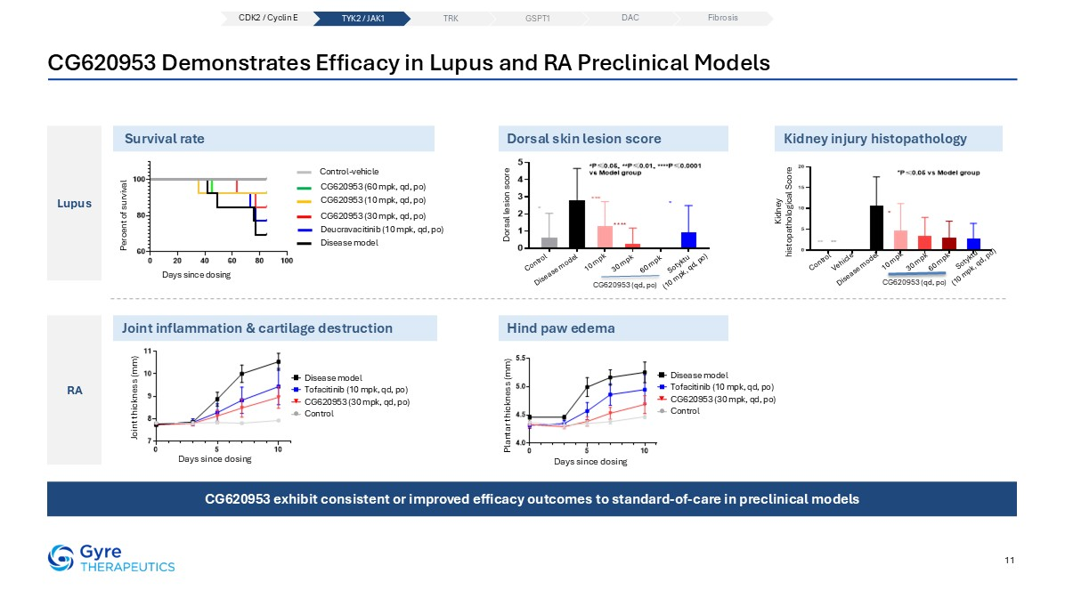
CG620953 Demonstrates Efficacy in Lupus and RA Preclinical Models 11 Lupus RA Percent of survival Days since dosing Control-vehicle Disease model CG620953 (10 mpk, qd, po) CG620953 (30 mpk, qd, po) CG620953 (60 mpk, qd, po) Deucravacitinib (10 mpk, qd, po) Survival rate Dorsal skin lesion score Kidney injury histopathology Joint inflammation & cartilage destruction Sotyktu (10 mpk, qd, po) Disease model 10 mpk Control 30 mpk 60 mpk CG620953 (qd, po) Dorsal lesion score Kidney histopathological Score Disease model 10 mpk Control 30 mpk 60 mpk CG620953 (qd, po) Vehicle Sotyktu (10 mpk, qd, po) Hind paw edema Days since dosing Plantar thickness (mm) Control Disease model CG620953 (30 mpk, qd, po) Tofacitinib (10 mpk, qd, po) Joint thickness (mm) Days since dosing Control Disease model CG620953 (30 mpk, qd, po) Tofacitinib (10 mpk, qd, po) CG620953 exhibit consistent or improved efficacy outcomes to standard-of-care in preclinical models CDK2 / Cyclin E TYK2 / JAK1 TRK DAC Fibrosis GSPT1

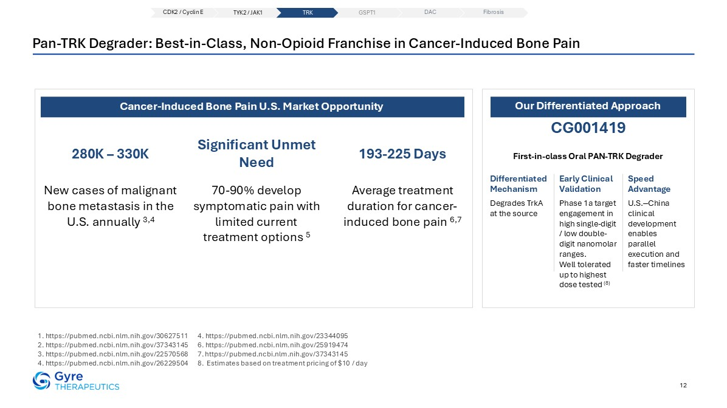
Pan-TRK Degrader: Best-in-Class, Non-Opioid Franchise in Cancer-Induced Bone Pain 1. https://pubmed.ncbi.nlm.nih.gov/30627511 2. https://pubmed.ncbi.nlm.nih.gov/37343145 3. https://pubmed.ncbi.nlm.nih.gov/22570568 4. https://pubmed.ncbi.nlm.nih.gov/26229504 4. https://pubmed.ncbi.nlm.nih.gov/23344095 6. https://pubmed.ncbi.nlm.nih.gov/25919474 7. https://pubmed.ncbi.nlm.nih.gov/37343145 8. Estimates based on treatment pricing of $10 / day CG001419 First-in-class Oral PAN-TRK Degrader Degrades TrkA at the source Phase 1a target engagement in high single-digit / low double-digit nanomolar ranges. Well tolerated up to highest dose tested (8) U.S.‒China clinical development enables parallel execution and faster timelines Differentiated Mechanism Early Clinical Validation Speed Advantage Our Differentiated Approach 12 New cases of malignant bone metastasis in the U.S. annually 3,4 280K – 330K Cancer-Induced Bone Pain U.S. Market Opportunity 70-90% develop symptomatic pain with limited current treatment options 5 Significant Unmet Need Average treatment duration for cancer-induced bone pain 6,7 193-225 Days CDK2 / Cyclin E TYK2 / JAK1 TRK DAC Fibrosis GSPT1

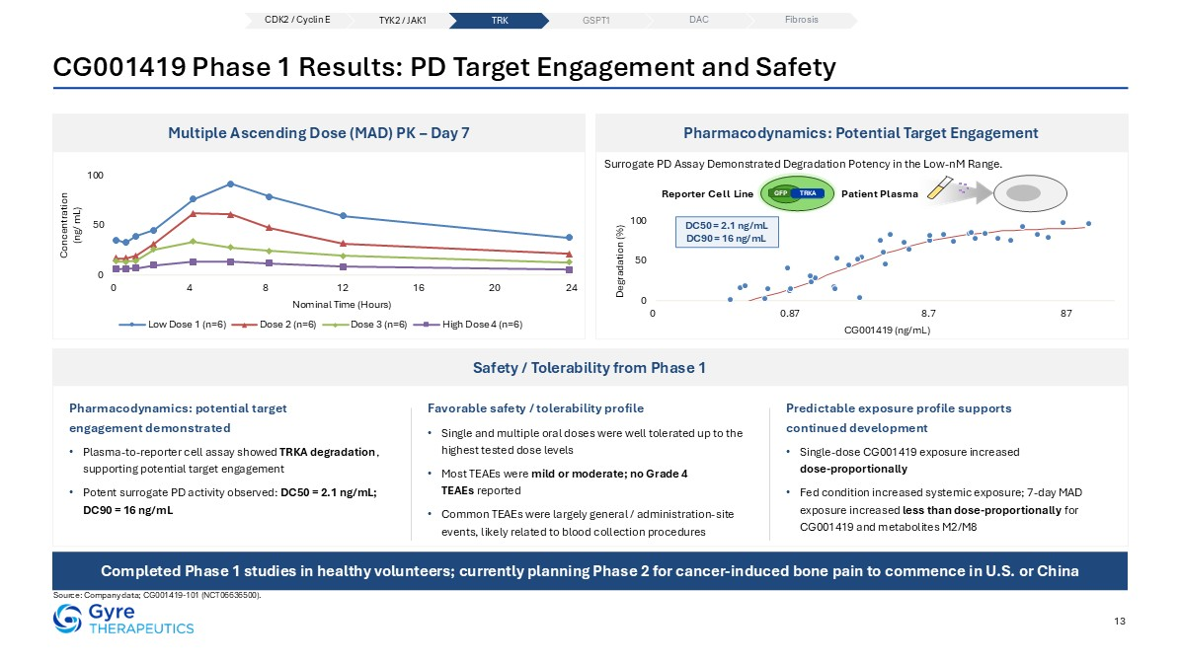
13 CG001419 Phase 1 Results: PD Target Engagement and Safety Source: Company data; CG001419-101 (NCT06636500). Pharmacodynamics: Potential Target Engagement Multiple Ascending Dose (MAD) PK – Day 7 Safety / Tolerability from Phase 1 Pharmacodynamics: potential target engagement demonstrated Plasma-to-reporter cell assay showed TRKA degradation, supporting potential target engagement Potent surrogate PD activity observed: DC50 = 2.1 ng/mL; DC90 = 16 ng/mL Favorable safety / tolerability profile Single and multiple oral doses were well tolerated up to the highest tested dose levels Most TEAEs were mild or moderate; no Grade 4 TEAEs reported Common TEAEs were largely general / administration-site events, likely related to blood collection procedures Predictable exposure profile supports continued development Single-dose CG001419 exposure increased dose-proportionally Fed condition increased systemic exposure; 7-day MAD exposure increased less than dose-proportionally for CG001419 and metabolites M2/M8 Surrogate PD Assay Demonstrated Degradation Potency in the Low-nM Range. GFP TRKA Patient Plasma Reporter Cell Line DC50 = 2.1 ng/mL DC90 = 16 ng/mL Completed Phase 1 studies in healthy volunteers; currently planning Phase 2 for cancer-induced bone pain to commence in U.S. or China CDK2 / Cyclin E TYK2 / JAK1 TRK DAC Fibrosis GSPT1

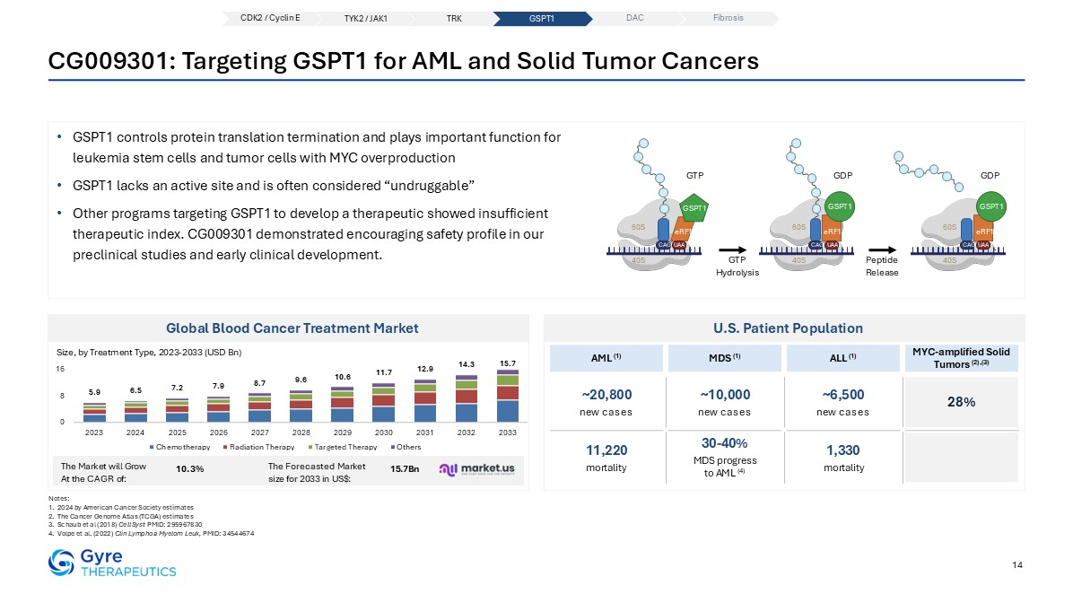
14 CG009301: Targeting GSPT1 for AML and Solid Tumor Cancers GSPT1 controls protein translation termination and plays important function for leukemia stem cells and tumor cells with MYC overproduction GSPT1 lacks an active site and is often considered “undruggable” Other programs targeting GSPT1 to develop a therapeutic showed insufficient therapeutic index. CG009301 demonstrated encouraging safety profile in our preclinical studies and early clinical development. Notes: 2024 by American Cancer Society estimates The Cancer Genome Atlas (TCGA) estimates Schaub et al (2018) Cell Syst PMID: 295967830 Volpe et al. (2022) Clin Lymphoa Myelom Leuk, PMID: 34544674 GTP Hydrolysis Peptide Release GTP GSPT1 60S CAG UAA 40S eRF1 GDP GSPT1 60S CAG UAA 40S eRF1 GDP GSPT1 60S CAG UAA 40S eRF1 Global Blood Cancer Treatment Market Size, by Treatment Type, 2023-2033 (USD Bn) U.S. Patient Population ~20,800 new cases ~10,000 new cases ~6,500 new cases 28% 11,220 mortality 1,330 mortality 30-40% MDS progress to AML (4) AML (1) MDS (1) ALL (1) MYC-amplified Solid Tumors (2),(3) The Market will Grow 10.3% The Forecasted Market 15.7Bn At the CAGR of: size for 2033 in US$: CDK2 / Cyclin E TYK2 / JAK1 TRK DAC Fibrosis GSPT1

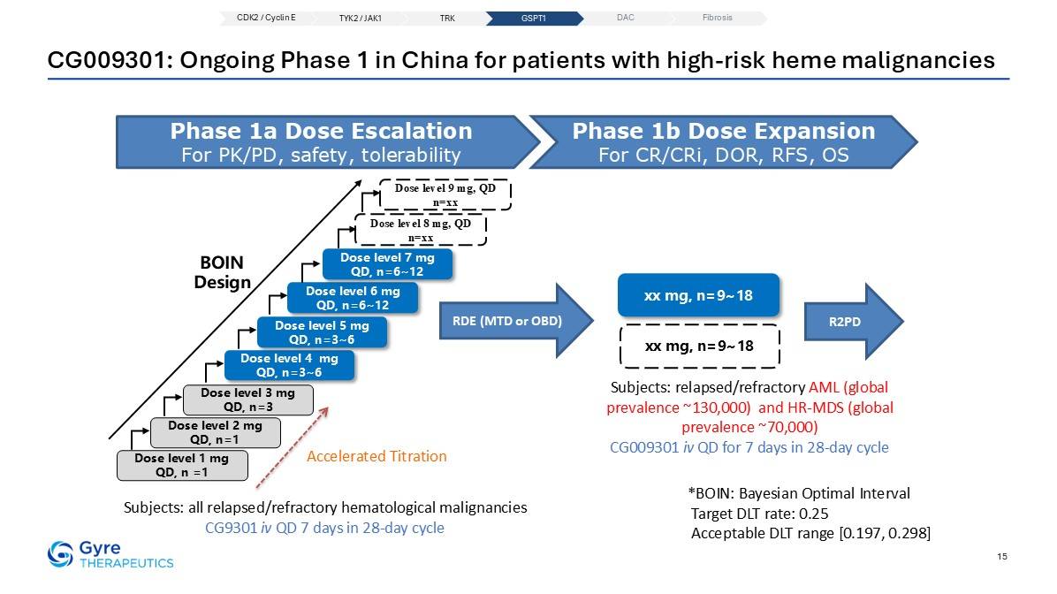
15 CG009301: Ongoing Phase 1 in China for patients with high-risk heme malignancies RDE (MTD or OBD) Phase 1a Dose Escalation For PK/PD, safety, tolerability Phase 1b Dose Expansion For CR/CRi, DOR, RFS, OS Dose level 1 mg QD, n =1 Dose level 2 mg QD, n=1 Dose level 3 mg QD, n=3 Dose level 6 mg QD, n=6~12 Dose level 7 mg QD, n=6~12 BOIN Design Dose level 8 mg, QD n=xx R2PD xx mg, n=9~18 xx mg, n=9~18 Dose level 4 mg QD, n=3~6 Dose level 5 mg QD, n=3~6 Dose level 9 mg, QD n=xx Accelerated Titration *BOIN: Bayesian Optimal Interval Target DLT rate: 0.25 Acceptable DLT range [0.197, 0.298] Subjects: all relapsed/refractory hematological malignancies CG9301 iv QD 7 days in 28-day cycle Subjects: relapsed/refractory AML (global prevalence ~130,000) and HR-MDS (global prevalence ~70,000) CG009301 iv QD for 7 days in 28-day cycle CDK2 / Cyclin E TYK2 / JAK1 TRK DAC Fibrosis GSPT1


Degrader-Antibody Conjugates (DACs)

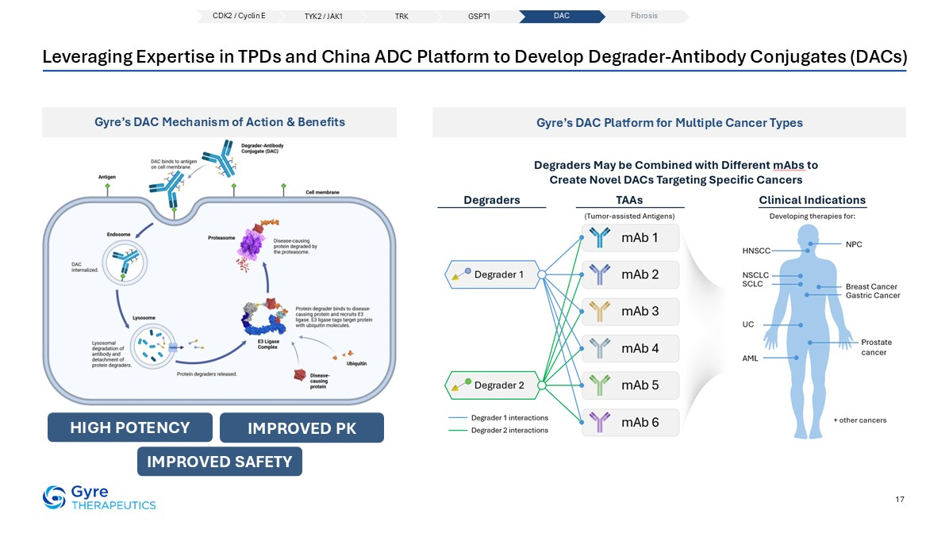
17 Leveraging Expertise in TPDs and China ADC Platform to Develop Degrader-Antibody Conjugates (DACs) Gyre’s DAC Platform for Multiple Cancer Types 24 HIGH POTENCY IMPROVED pk Gyre’s DAC Mechanism of Action & Benefits IMPROVED SAFETY 17 CDK2 / Cyclin E TYK2 / JAK1 TRK DAC Fibrosis GSPT1

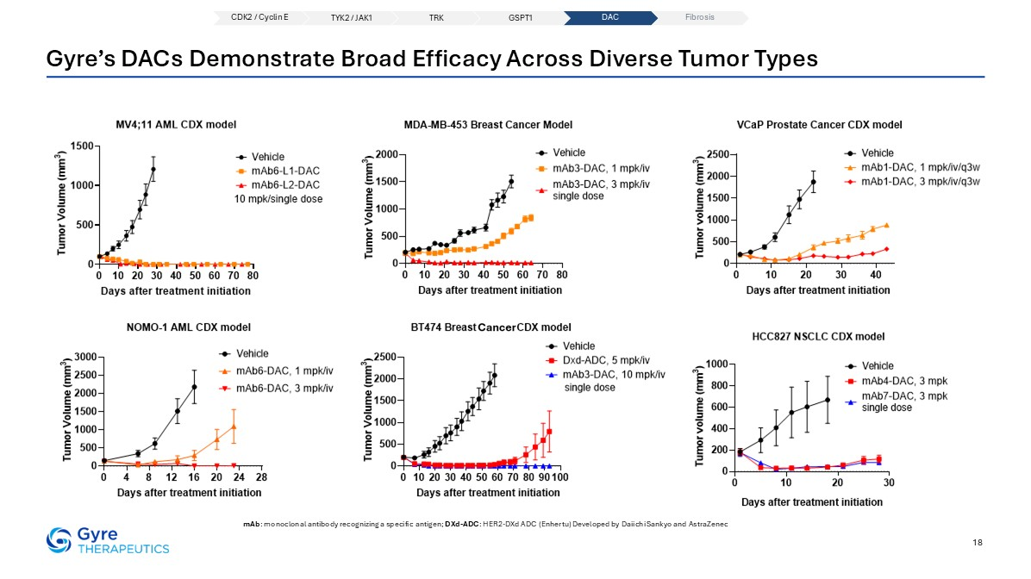
Gyre’s DACs Demonstrate Broad Efficacy Across Diverse Tumor Types mAb: monoclonal antibody recognizing a specific antigen; DXd-ADC: HER2-DXd ADC (Enhertu) Developed by Daiichi Sankyo and AstraZenec 18 CDK2 / Cyclin E TYK2 / JAK1 TRK DAC Fibrosis GSPT1

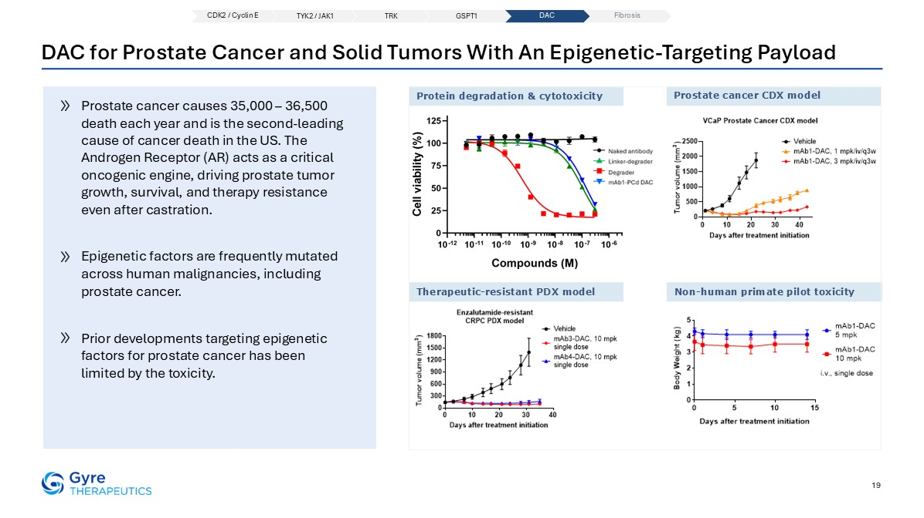
DAC for Prostate Cancer and Solid Tumors With An Epigenetic-Targeting Payload Therapeutic-resistant PDX model Prostate cancer CDX model Non-human primate pilot toxicity Prostate cancer causes 35,000 – 36,500 death each year and is the second-leading cause of cancer death in the US. The Androgen Receptor (AR) acts as a critical oncogenic engine, driving prostate tumor growth, survival, and therapy resistance even after castration. Epigenetic factors are frequently mutated across human malignancies, including prostate cancer. Prior developments targeting epigenetic factors for prostate cancer has been limited by the toxicity. Protein degradation & cytotoxicity 19 CDK2 / Cyclin E TYK2 / JAK1 TRK DAC Fibrosis GSPT1


Commercial Foundation and Growth Opportunities with F351 (Hydronidone)

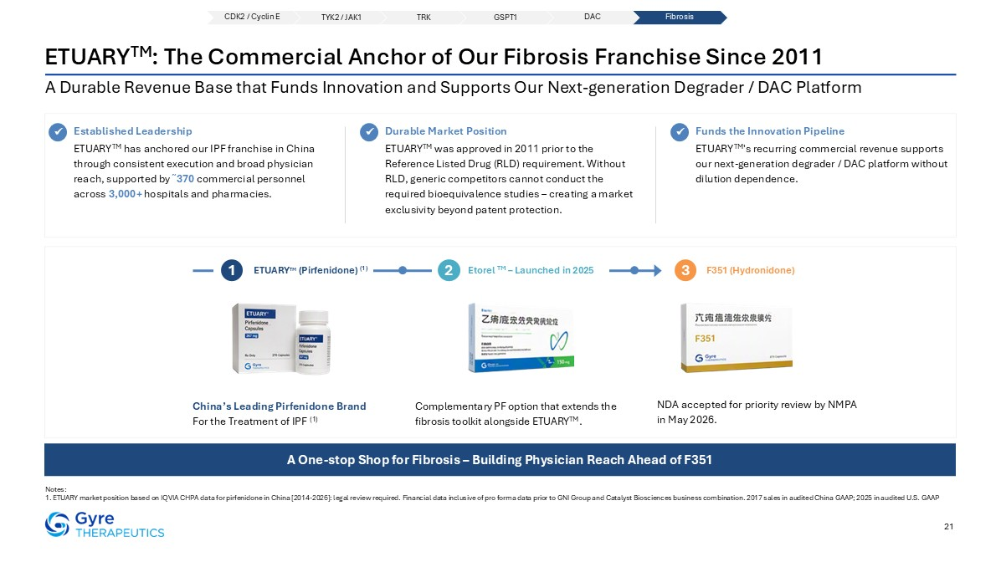
ETUARYTM: The Commercial Anchor of Our Fibrosis Franchise Since 2011 A Durable Revenue Base that Funds Innovation and Supports Our Next-generation Degrader / DAC Platform Notes: 1. ETUARY market position based on IQVIA CHPA data for pirfenidone in China [2014-2026]: legal review required. Financial data inclusive of pro forma data prior to GNI Group and Catalyst Biosciences business combination. 2017 sales in audited China GAAP; 2025 in audited U.S. GAAP 21 Established Leadership ETUARYTM has anchored our IPF franchise in China through consistent execution and broad physician reach, supported by ῀370 commercial personnel across 3,000+ hospitals and pharmacies. Durable Market Position ETUARYTM was approved in 2011 prior to the Reference Listed Drug (RLD) requirement. Without RLD, generic competitors cannot conduct the required bioequivalence studies – creating a market exclusivity beyond patent protection. Funds the Innovation Pipeline ETUARYTM’s recurring commercial revenue supports our next-generation degrader / DAC platform without dilution dependence. ✓ ✓ ✓ ETUARYTM (Pirfenidone) (1) 1 Etorel TM – Launched in 2025 2 F351 (Hydronidone) 3 China’s Leading Pirfenidone Brand For the Treatment of IPF (1) Complementary PF option that extends the fibrosis toolkit alongside ETUARYTM. NDA accepted for priority review by NMPA in May 2026. A One-stop Shop for Fibrosis – Building Physician Reach Ahead of F351 CDK2 / Cyclin E TYK2 / JAK1 TRK DAC Fibrosis GSPT1

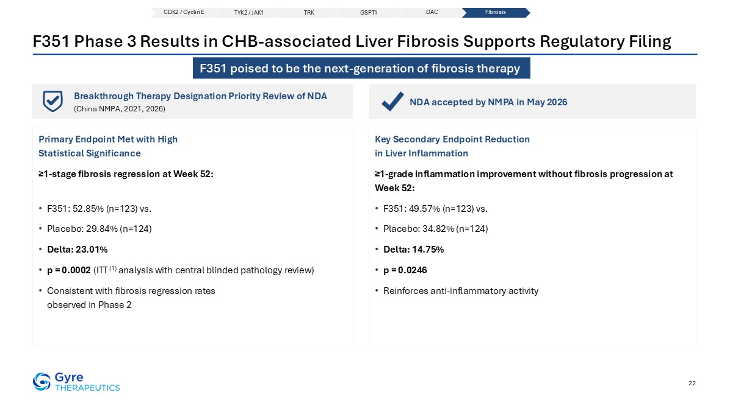
Breakthrough Therapy Designation Priority Review of NDA (China NMPA, 2021, 2026) NDA accepted by NMPA in May 2026 22 F351 Phase 3 Results in CHB-associated Liver Fibrosis Supports Regulatory Filing Primary Endpoint Met with High Statistical Significance ≥1-stage fibrosis regression at Week 52: F351: 52.85% (n=123) vs. Placebo: 29.84% (n=124) Delta: 23.01% p = 0.0002 (ITT (1) analysis with central blinded pathology review) Consistent with fibrosis regression rates observed in Phase 2 Key Secondary Endpoint Reduction in Liver Inflammation ≥1-grade inflammation improvement without fibrosis progression at Week 52: F351: 49.57% (n=123) vs. Placebo: 34.82% (n=124) Delta: 14.75% p = 0.0246 Reinforces anti-inflammatory activity CDK2 / Cyclin E TYK2 / JAK1 TRK DAC Fibrosis GSPT1 F351 poised to be the next-generation of fibrosis therapy

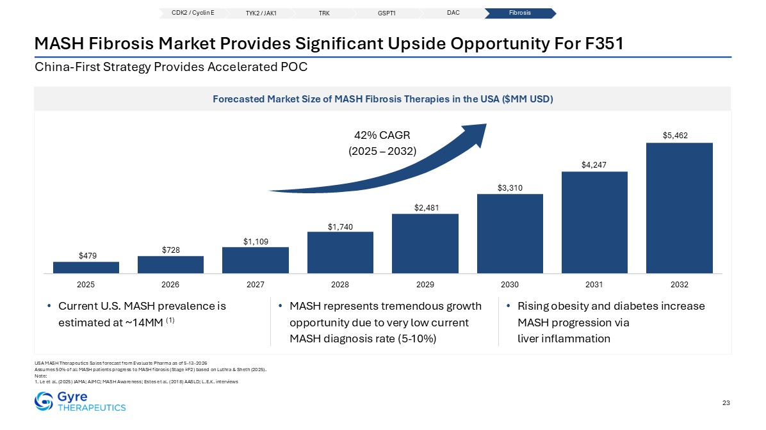
China-First Strategy Provides Accelerated POC 23 MASH Fibrosis Market Provides Significant Upside Opportunity For F351 Forecasted Market Size of MASH Fibrosis Therapies in the USA ($MM USD) USA MASH Therapeutics Sales forecast from Evaluate Pharma as of 5-13-2026 Assumes 50% of all MASH patients progress to MASH fibrosis (Stage ≥F2) based on Luthra & Sheth (2025). Note: 1. Le et al. (2025) JAMA; AJMC; MASH Awareness; Estes et al. (2018) AASLD; L.E.K. interviews Current U.S. MASH prevalence is estimated at ~14MM (1) MASH represents tremendous growth opportunity due to very low current MASH diagnosis rate (5-10%) Rising obesity and diabetes increase MASH progression via liver inflammation 42% CAGR (2025 – 2032) CDK2 / Cyclin E TYK2 / JAK1 TRK DAC Fibrosis GSPT1

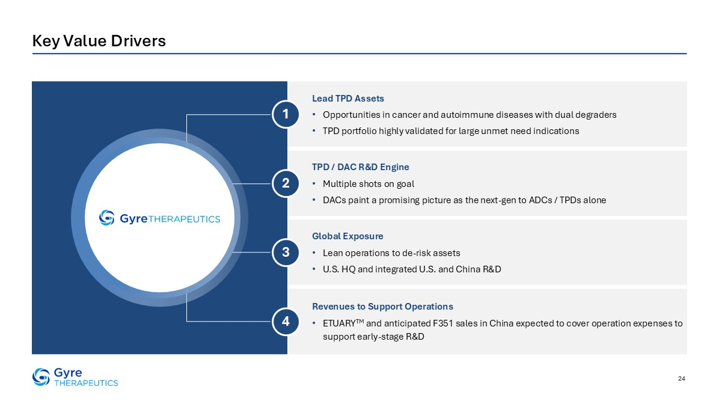
24 Key Value Drivers Lead TPD Assets Opportunities in cancer and autoimmune diseases with dual degraders TPD portfolio highly validated for large unmet need indications TPD / DAC R&D Engine Multiple shots on goal DACs paint a promising picture as the next-gen to ADCs / TPDs alone Global Exposure Lean operations to de-risk assets U.S. HQ and integrated U.S. and China R&D Revenues to Support Operations ETUARYTM and anticipated F351 sales in China expected to cover operation expenses to support early-stage R&D 1 2 3 4


Thank You!


1 Appendix

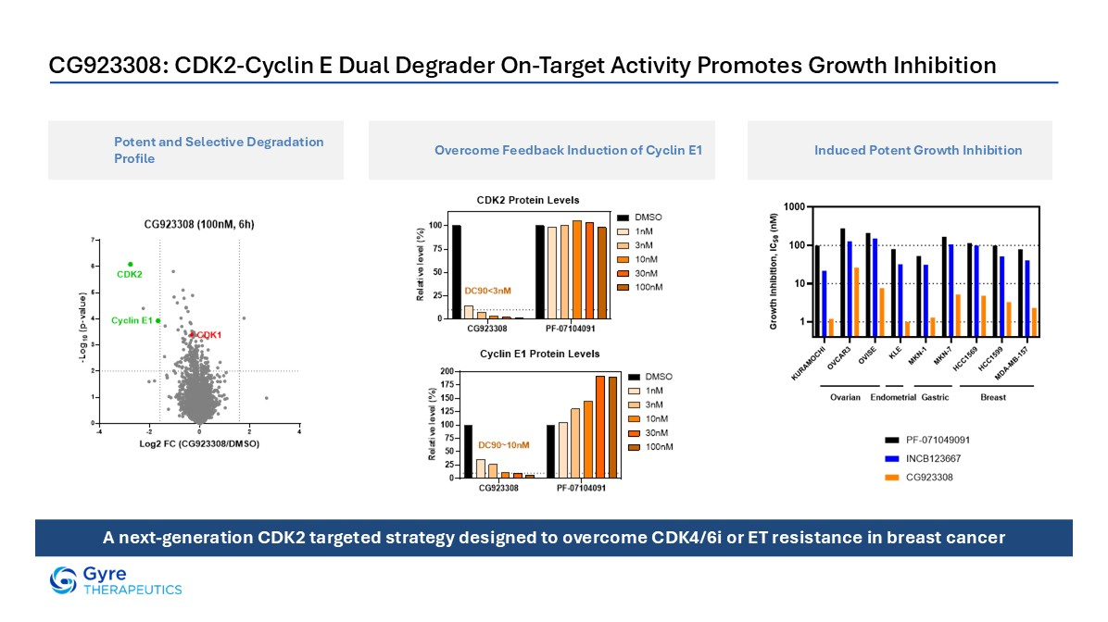
CG923308: CDK2-Cyclin E Dual Degrader On-Target Activity Promotes Growth Inhibition Potent and Selective Degradation Profile Overcome Feedback Induction of Cyclin E1 Induced Potent Growth Inhibition A next-generation CDK2 targeted strategy designed to overcome CDK4/6i or ET resistance in breast cancer

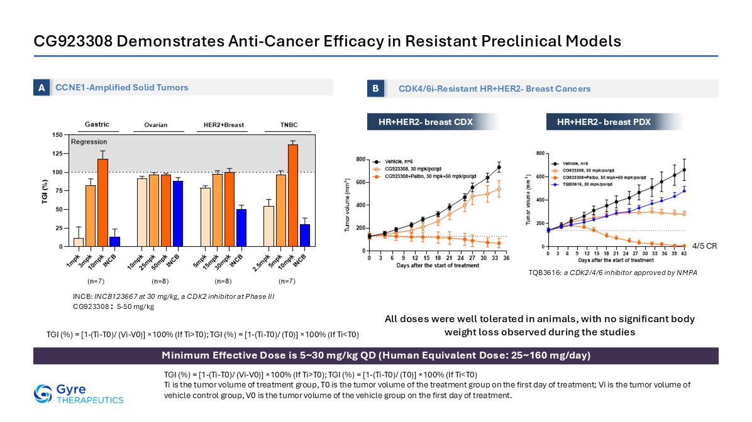
CG923308 Demonstrates Anti-Cancer Efficacy in Resistant Preclinical Models Minimum Effective Dose is 5~30 mg/kg QD (Human Equivalent Dose: 25~160 mg/day) HR+HER2- breast CDX CCNE1-Amplified Solid Tumors A CDK4/6i-Resistant HR+HER2- Breast Cancers B HR+HER2- breast PDX 4/5 CR All doses were well tolerated in animals, with no significant body weight loss observed during the studies TGI (%) = [1-(Ti-T0)/ (Vi-V0)] ×100% (If Ti>T0); TGI (%) = [1-(Ti-T0)/ (T0)] ×100% (If Ti<T0) Ti is the tumor volume of treatment group, T0 is the tumor volume of the treatment group on the first day of treatment; Vi is the tumor volume of vehicle control group, V0 is the tumor volume of the vehicle group on the first day of treatment. INCB: INCB123667 at 30 mg/kg, a CDK2 inhibitor at Phase III CG923308：5-50 mg/kg TQB3616: a CDK2/4/6 inhibitor approved by NMPA TGI (%) = [1-(Ti-T0)/ (Vi-V0)] ×100% (If Ti>T0); TGI (%) = [1-(Ti-T0)/ (T0)] ×100% (If Ti<T0)

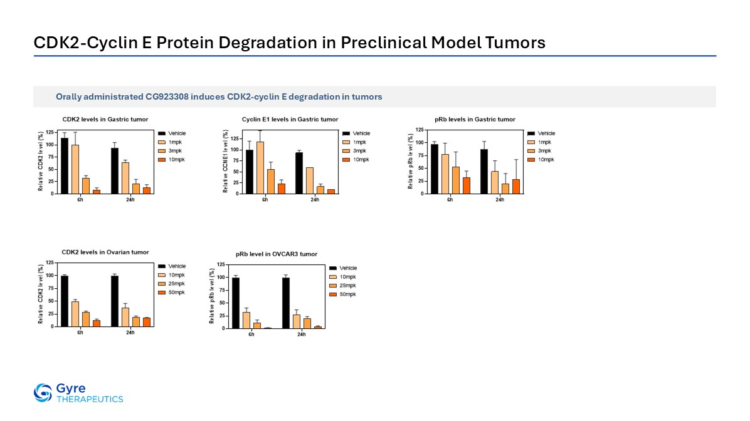
CDK2-Cyclin E Protein Degradation in Preclinical Model Tumors Orally administrated CG923308 induces CDK2-cyclin E degradation in tumors

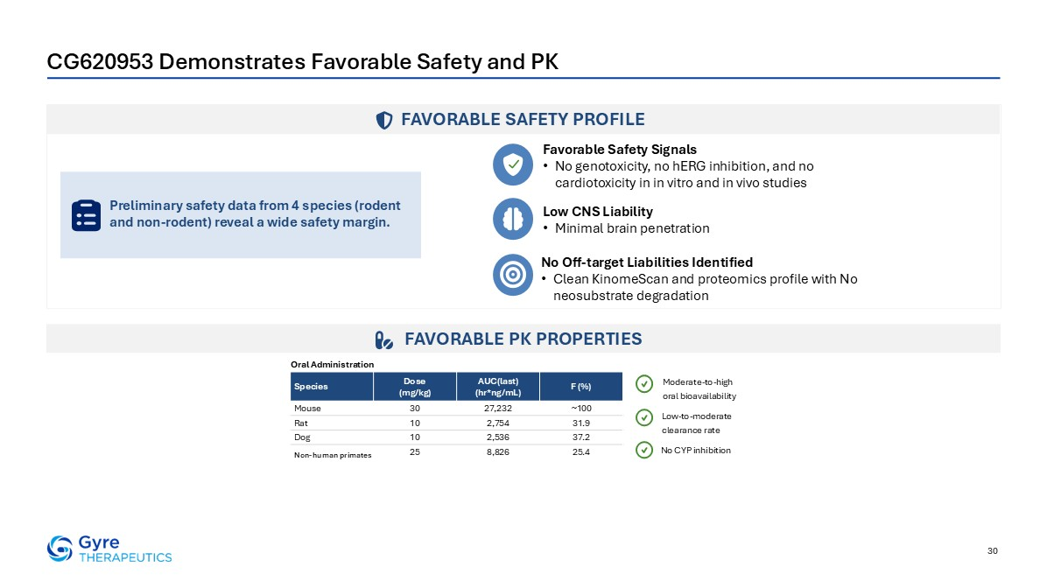
CG620953 Demonstrates Favorable Safety and PK 30 FAVORABLE SAFETY PROFILE FAVORABLE PK PROPERTIES Favorable Safety Signals No genotoxicity, no hERG inhibition, and no cardiotoxicity in in vitro and in vivo studies No Off-target Liabilities Identified Clean KinomeScan and proteomics profile with No neosubstrate degradation Low CNS Liability Minimal brain penetration Preliminary safety data from 4 species (rodent and non-rodent) reveal a wide safety margin. Species Dose (mg/kg) AUC(last) (hr*ng/mL) F (%) Mouse 30 27,232 ~100 Rat 10 2,754 31.9 Dog 10 2,536 37.2 Monkey 25 8,826 25.4 Oral Administration Moderate-to-high oral bioavailability Low-to-moderate clearance rate No CYP inhibition Non-human primates

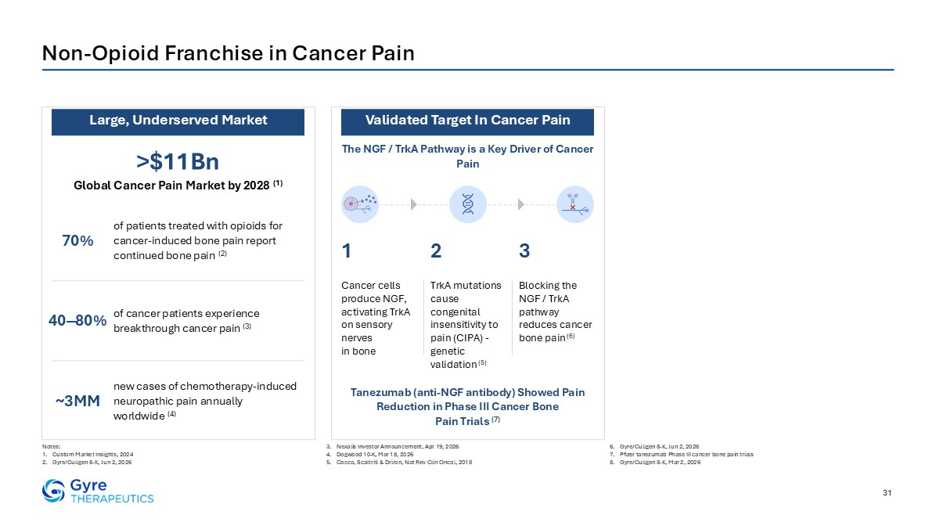
31 Non-Opioid Franchise in Cancer Pain Notes: Custom Market Insights, 2024 Gyre/Cullgen 8-K, Jun 2, 2026 Nexalis Investor Announcement, Apr 19, 2026 Dogwood 10-K, Mar 18, 2026 Cocco, Scaltriti & Dri/on, Nat Rev Clin Oncol, 2018 Gyre/Cullgen 8-K, Jun 2, 2026 Pfizer tanezumab Phase III cancer bone pain trials Gyre/Cullgen 8-K, Mar 2, 2026 >$11Bn Global Cancer Pain Market by 2028 (1) The NGF / TrkA Pathway is a Key Driver of Cancer Pain of patients treated with opioids for cancer-induced bone pain report continued bone pain (2) 70% of cancer patients experience breakthrough cancer pain (3) 40‒80% new cases of chemotherapy-induced neuropathic pain annually worldwide (4) ~3MM Tanezumab (anti-NGF antibody) Showed Pain Reduction in Phase III Cancer Bone Pain Trials (7) Cancer cells produce NGF, activating TrkA on sensory nerves in bone TrkA mutations cause congenital insensitivity to pain (CIPA) - genetic validation (5) Blocking the NGF / TrkA pathway reduces cancer bone pain (6) 1 2 3 Large, Underserved Market Validated Target In Cancer Pain

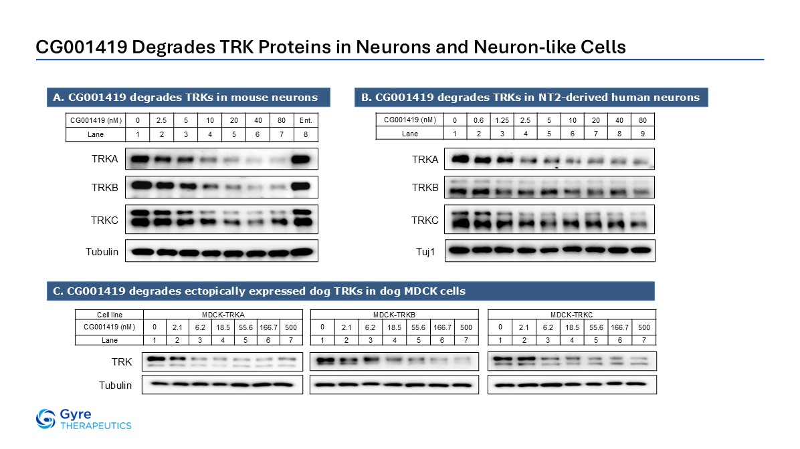
CG001419 Degrades TRK Proteins in Neurons and Neuron-like Cells CG001419 (nM) 0 0.6 1.25 2.5 5 10 20 40 80 Lane 1 2 3 4 5 6 7 8 9 CG001419 (nM) 0 2.5 5 10 20 40 80 Ent. Lane 1 2 3 4 5 6 7 8 TRKB TRKB TRKC TRKC TRKA TRKA Tuj1 CG001419 degrades TRKs in mouse neurons B. CG001419 degrades TRKs in NT2-derived human neurons Tubulin C. CG001419 degrades ectopically expressed dog TRKs in dog MDCK cells Cell line MDCK-TRKA CG001419 (nM) 0 2.1 6.2 18.5 55.6 166.7 500 Lane 1 2 3 4 5 6 7 TRK Tubulin MDCK-TRKC 0 2.1 6.2 18.5 55.6 166.7 500 1 2 3 4 5 6 7 MDCK-TRKB 0 2.1 6.2 18.5 55.6 166.7 500 1 2 3 4 5 6 7

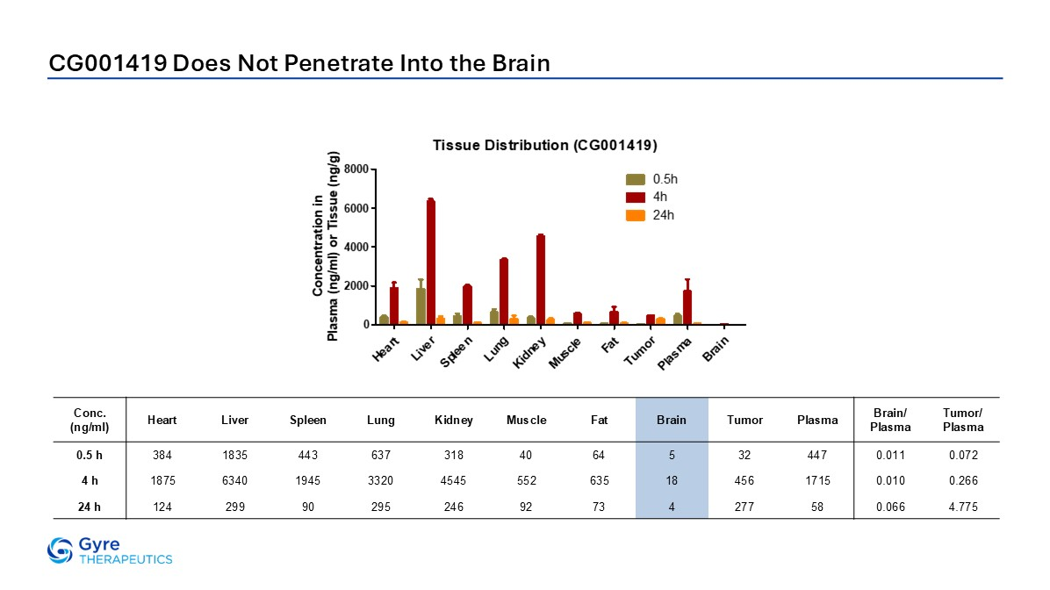
CG001419 Does Not Penetrate Into the Brain Conc. (ng/ml) Heart Liver Spleen Lung Kidney Muscle Fat Brain Tumor Plasma Brain/ Plasma Tumor/ Plasma 0.5 h 384 1835 443 637 318 40 64 5 32 447 0.011 0.072 4 h 1875 6340 1945 3320 4545 552 635 18 456 1715 0.010 0.266 24 h 124 299 90 295 246 92 73 4 277 58 0.066 4.775

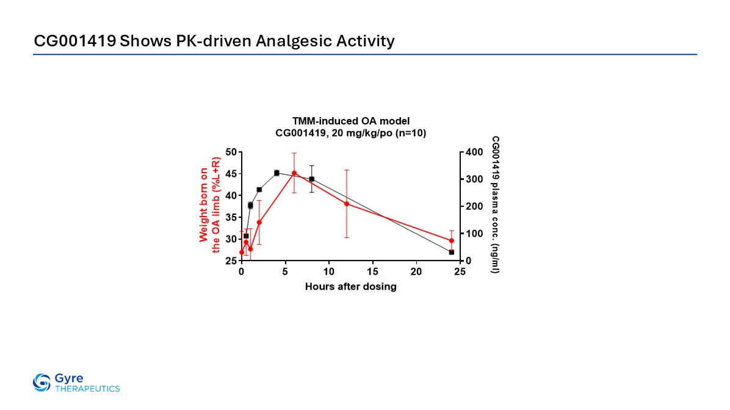
CG001419 Shows PK-driven Analgesic Activity

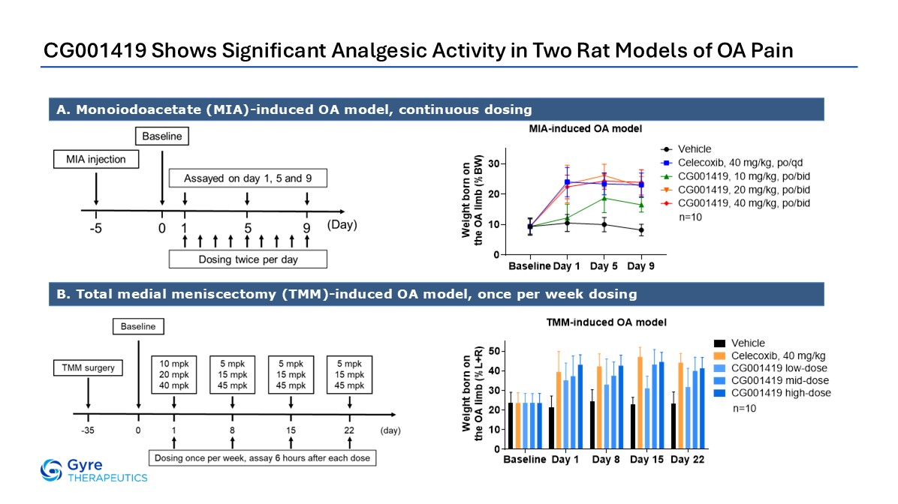
CG001419 Shows Significant Analgesic Activity in Two Rat Models of OA Pain A. Monoiodoacetate (MIA)-induced OA model, continuous dosing B. Total medial meniscectomy (TMM)-induced OA model, once per week dosing

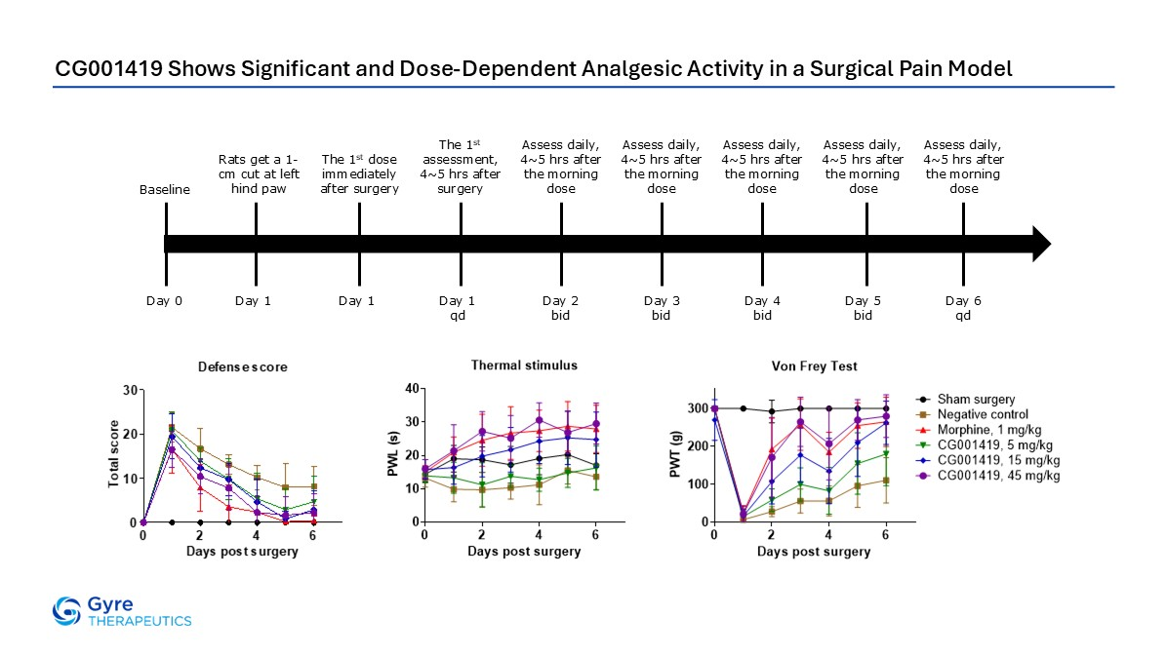
CG001419 Shows Significant and Dose-Dependent Analgesic Activity in a Surgical Pain Model Baseline Day 0 Rats get a 1-cm cut at left hind paw Day 1 Day 1 The 1st dose immediately after surgery Day 1 qd The 1st assessment, 4~5 hrs after surgery Day 2 bid Assess daily, 4~5 hrs after the morning dose Day 3 bid Assess daily, 4~5 hrs after the morning dose Day 4 bid Assess daily, 4~5 hrs after the morning dose Day 5 bid Assess daily, 4~5 hrs after the morning dose Day 6 qd Assess daily, 4~5 hrs after the morning dose

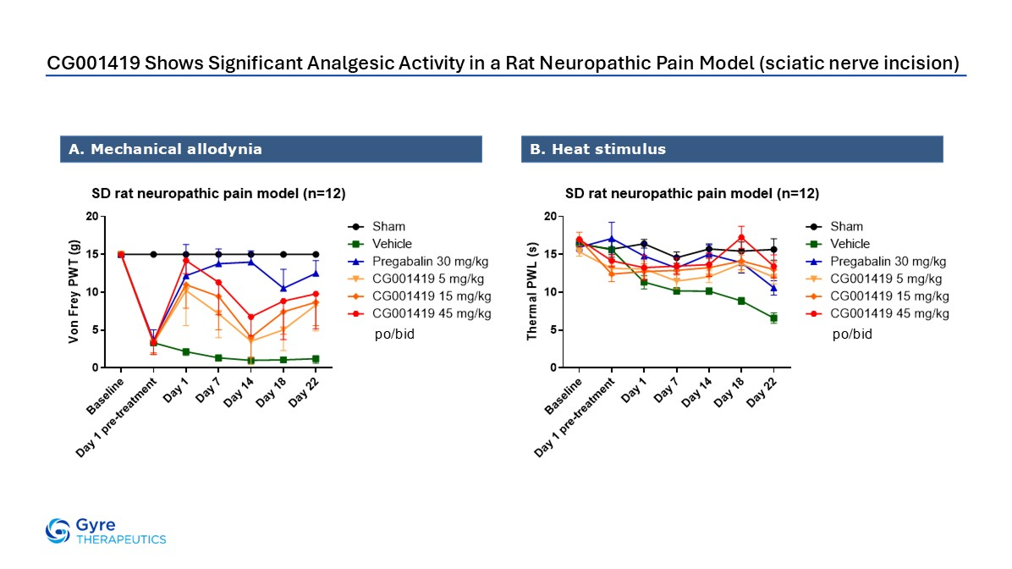
CG001419 Shows Significant Analgesic Activity in a Rat Neuropathic Pain Model (sciatic nerve incision) A. Mechanical allodynia B. Heat stimulus po/bid po/bid

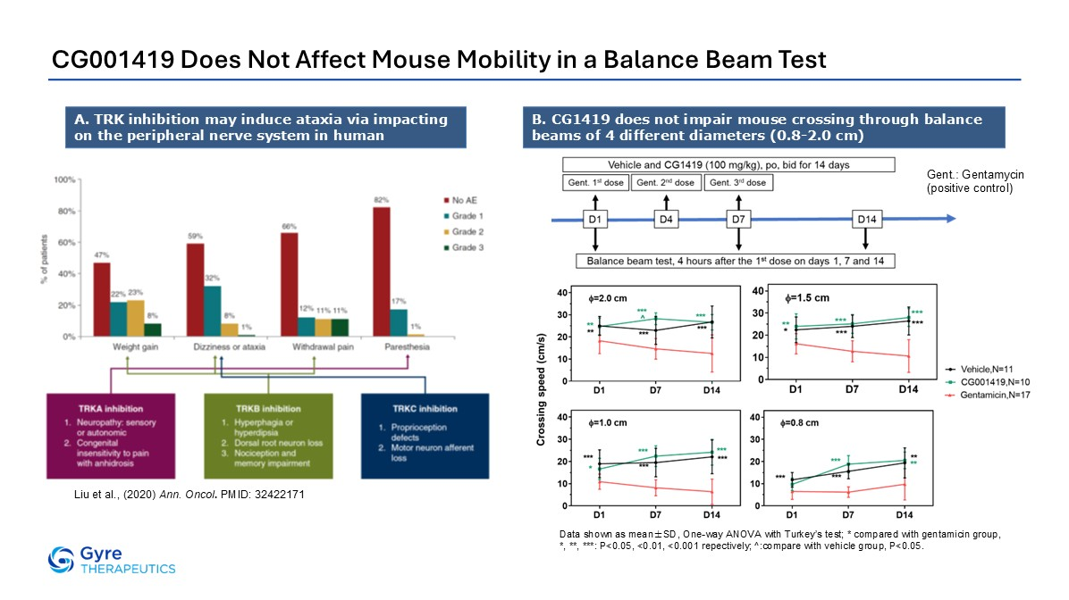
CG001419 Does Not Affect Mouse Mobility in a Balance Beam Test B. CG1419 does not impair mouse crossing through balance beams of 4 different diameters (0.8-2.0 cm) Gent.: Gentamycin (positive control) Data shown as mean±SD, One-way ANOVA with Turkey’s test; * compared with gentamicin group, *, **, ***: P<0.05, <0.01, <0.001 repectively; ^:compare with vehicle group, P<0.05. A. TRK inhibition may induce ataxia via impacting on the peripheral nerve system in human Liu et al., (2020) Ann. Oncol. PMID: 32422171

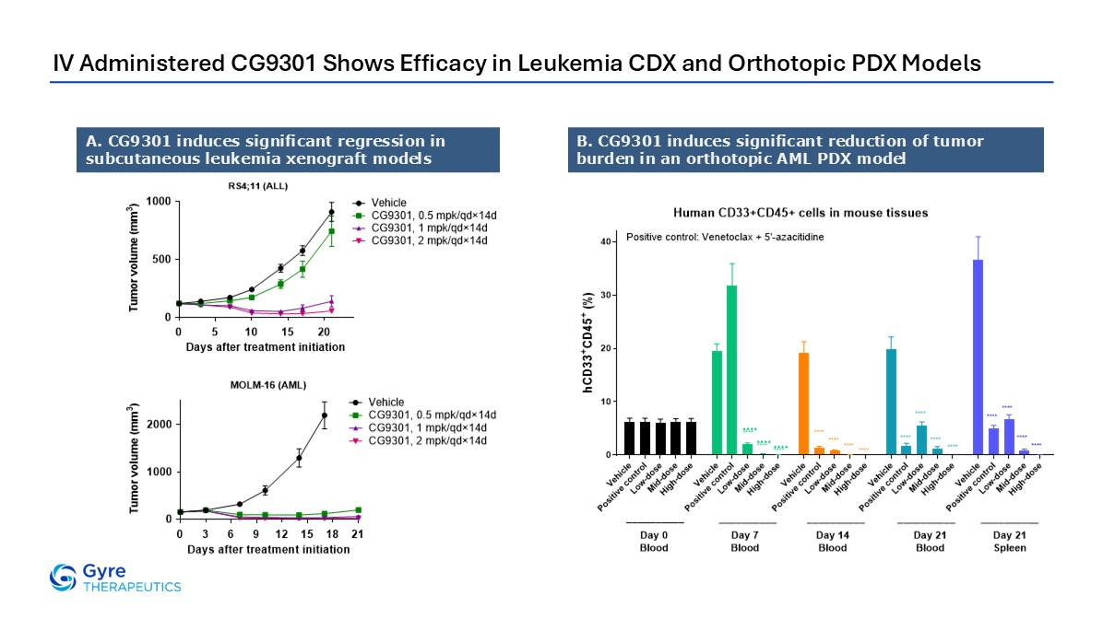
IV Administered CG9301 Shows Efficacy in Leukemia CDX and Orthotopic PDX Models A. CG9301 induces significant regression in subcutaneous leukemia xenograft models B. CG9301 induces significant reduction of tumor burden in an orthotopic AML PDX model

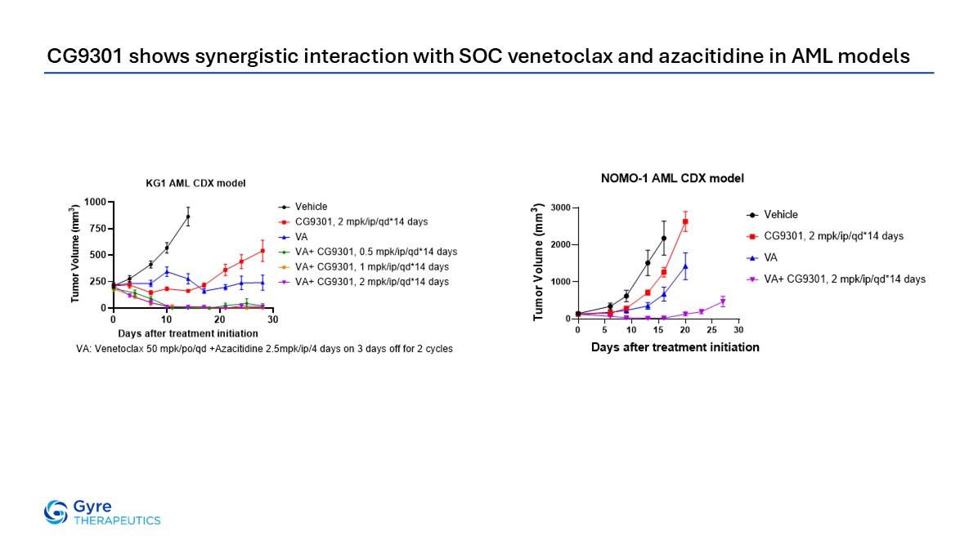
CG9301 shows synergistic interaction with SOC venetoclax and azacitidine in AML models

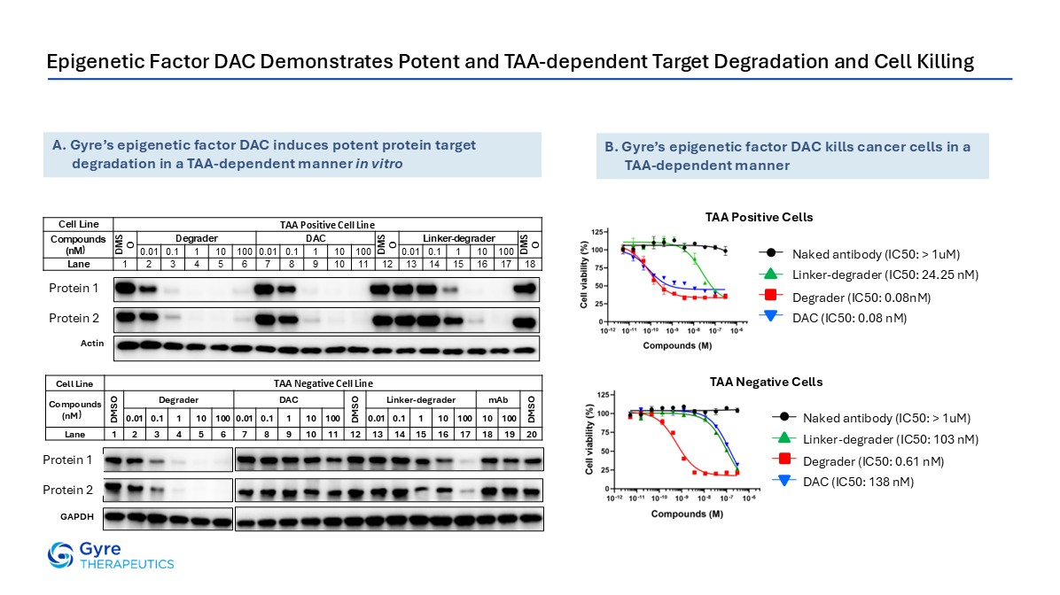
Epigenetic Factor DAC Demonstrates Potent and TAA-dependent Target Degradation and Cell Killing Cell Line TAA Positive Cell Line Compounds (nM） DMSO Degrader DAC DMSO Linker-degrader DMSO 0.01 0.1 1 10 100 0.01 0.1 1 10 100 0.01 0.1 1 10 100 Lane 1 2 3 4 5 6 7 8 9 10 11 12 13 14 15 16 17 18 Cell Line TAA Negative Cell Line Compounds (nM） DMSO Degrader DAC DMSO Linker- degrader mAb DMSO 0.01 0.1 1 10 100 0.01 0.1 1 10 100 0.01 0.1 1 10 100 10 100 Lane 1 2 3 4 5 6 7 8 9 10 11 12 13 14 15 16 17 18 19 20 p300 CBP Actin p300 CBP GAPDH A. Gyre’s epigenetic factor DAC induces potent protein target degradation in a TAA-dependent manner in vitro B. Gyre’s epigenetic factor DAC kills cancer cells in a TAA-dependent manner Linker-degrader (IC50: 24.25 nM) Naked antibody (IC50: > 1uM) Degrader (IC50: 0.08nM) DAC (IC50: 0.08 nM) TAA Positive Cells Linker-degrader (IC50: 103 nM) Naked antibody (IC50: > 1uM) Degrader (IC50: 0.61 nM) DAC (IC50: 138 nM) TAA Negative Cells Protein 1 Protein 2 Protein 1 Protein 2

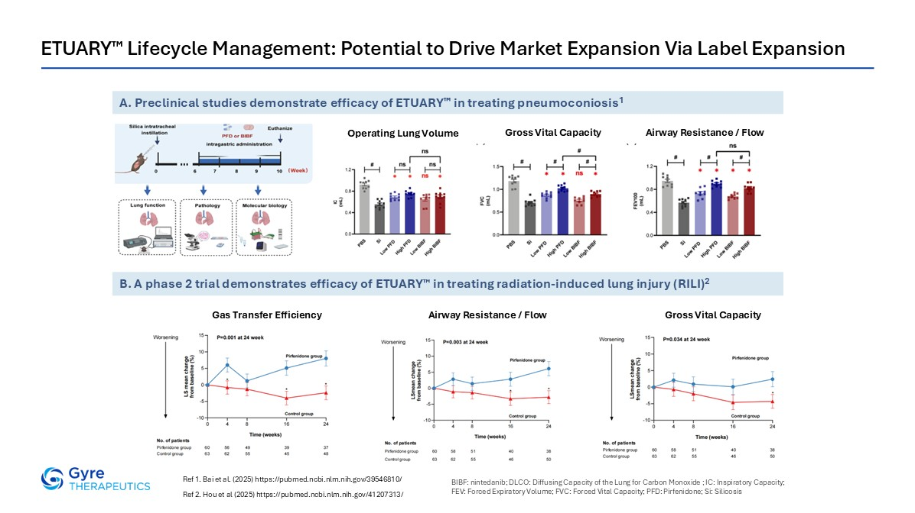
ETUARY™ Lifecycle Management: Potential to Drive Market Expansion Via Label Expansion Ref 1. Bai et al. (2025) https://pubmed.ncbi.nlm.nih.gov/39546810/ Ref 2. Hou et al (2025) https://pubmed.ncbi.nlm.nih.gov/41207313/ B. A phase 2 trial demonstrates efficacy of ETUARY™ in treating radiation-induced lung injury (RILI)2 A. Preclinical studies demonstrate efficacy of ETUARY™ in treating pneumoconiosis1 Gross Vital Capacity Gas Transfer Efficiency Airway Resistance / Flow BIBF: nintedanib; DLCO: Diffusing Capacity of the Lung for Carbon Monoxide ; IC: Inspiratory Capacity; FEV: Forced Expiratory Volume; FVC: Forced Vital Capacity; PFD: Pirfenidone; Si: Silicosis Operating Lung Volume Gross Vital Capacity Airway Resistance / Flow

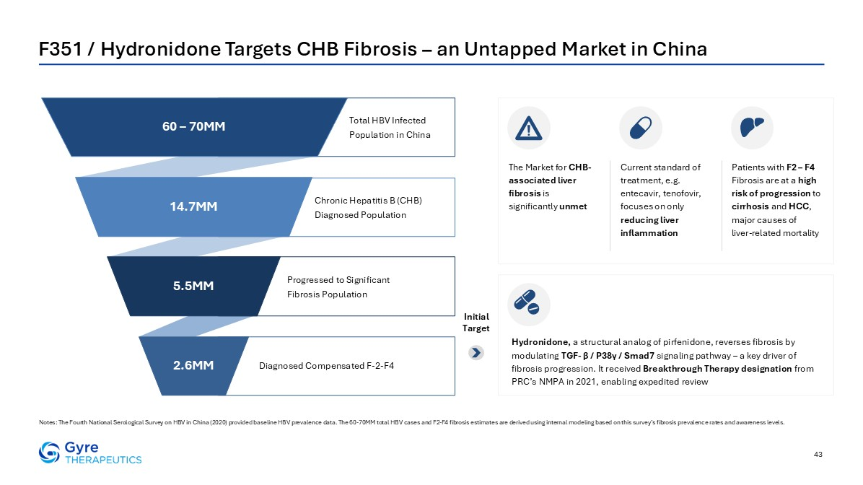
F351 / Hydronidone Targets CHB Fibrosis – an Untapped Market in China Notes: The Fourth National Serological Survey on HBV in China (2020) provided baseline HBV prevalence data. The 60-70MM total HBV cases and F2-F4 fibrosis estimates are derived using internal modeling based on this survey’s fibrosis prevalence rates and awareness levels. 43 Total HBV Infected Population in China Diagnosed Compensated F-2-F4 Progressed to Significant Fibrosis Population Chronic Hepatitis B (CHB) Diagnosed Population 60 – 70MM 14.7MM 5.5MM 2.6MM Hydronidone, a structural analog of pirfenidone, reverses fibrosis by modulating TGF- β / P38γ / Smad7 signaling pathway – a key driver of fibrosis progression. It received Breakthrough Therapy designation from PRC’s NMPA in 2021, enabling expedited review Initial Target The Market for CHB-associated liver fibrosis is significantly unmet Current standard of treatment, e.g. entecavir, tenofovir, focuses on only reducing liver inflammation Patients with F2 – F4 Fibrosis are at a high risk of progression to cirrhosis and HCC, major causes of liver-related mortality

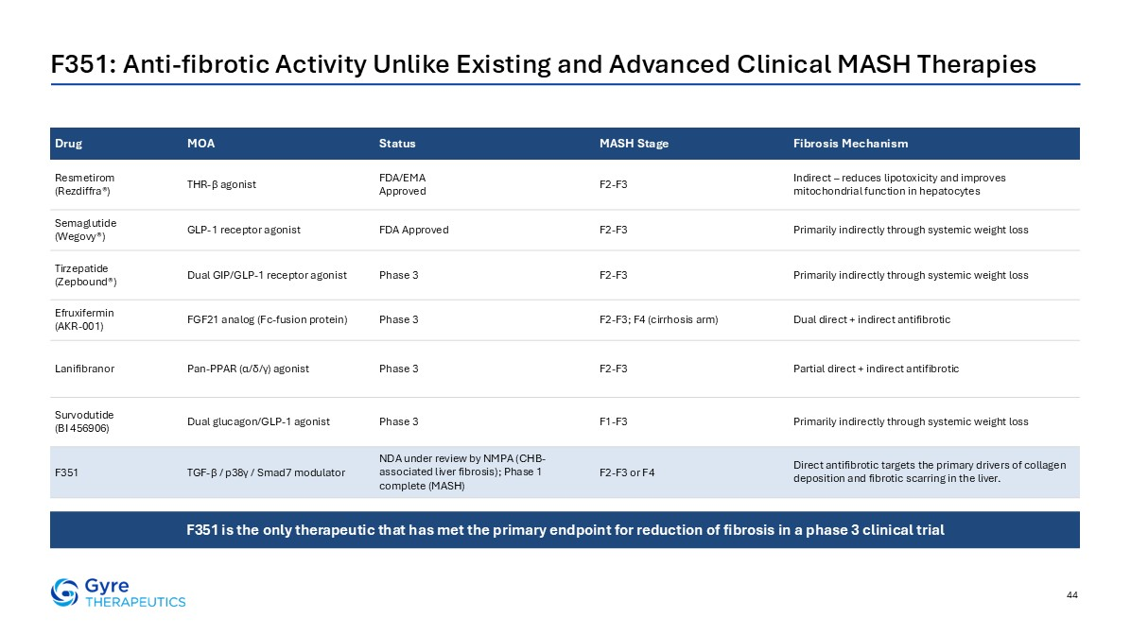
44 F351: Anti-fibrotic Activity Unlike Existing and Advanced Clinical MASH Therapies Drug MOA Status MASH Stage Fibrosis Mechanism Resmetirom (Rezdiffra®) THR-β agonist FDA/EMA Approved F2-F3 Indirect – reduces lipotoxicity and improves mitochondrial function in hepatocytes Semaglutide (Wegovy®) GLP-1 receptor agonist FDA Approved F2-F3 Primarily indirectly through systemic weight loss Tirzepatide (Zepbound®) Dual GIP/GLP-1 receptor agonist Phase 3 F2-F3 Primarily indirectly through systemic weight loss Efruxifermin (AKR-001) FGF21 analog (Fc-fusion protein) Phase 3 F2-F3; F4 (cirrhosis arm) Dual direct + indirect antifibrotic Lanifibranor Pan-PPAR (α/δ/γ) agonist Phase 3 F2-F3 Partial direct + indirect antifibrotic Survodutide (BI 456906) Dual glucagon/GLP-1 agonist Phase 3 F1-F3 Primarily indirectly through systemic weight loss F351 TGF-β / p38γ / Smad7 modulator NDA under review by NMPA (CHB-associated liver fibrosis); Phase 1 complete (MASH) F2-F3 or F4 Direct antifibrotic targets the primary drivers of collagen deposition and fibrotic scarring in the liver. Source: CapIQ, Company Filings F351 is the only therapeutic that has met the primary endpoint for reduction of fibrosis in a phase 3 clinical trial

